**Project Title: Project Design Phase-I** – **problem solution fit template Team ID: PNT2022TMID44952**

Real Time communication system powered by AI for specially abled

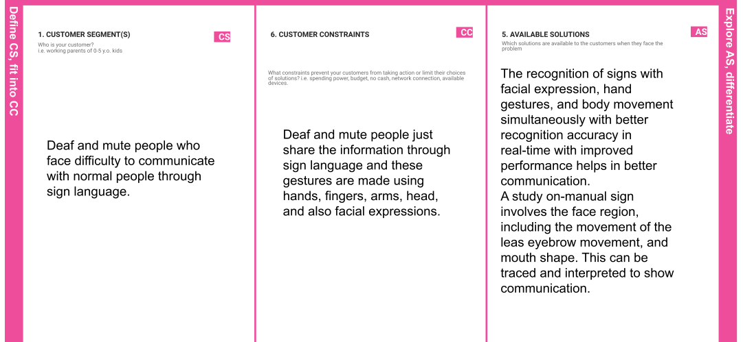

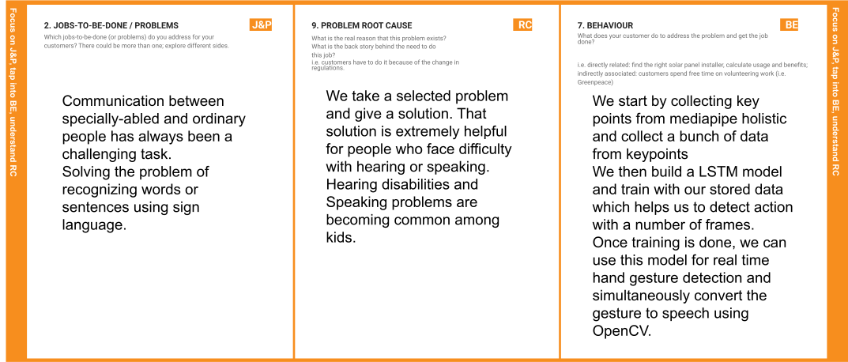

|  |  |  |  |  |
| --- | --- | --- | --- | --- |
|  | **3. TRIGGERS**  **TR**  What triggers customers to act? i.e. seeing their neighbour installing solar panels, reading about a more efficient solution in the news. | **10. YOUR SOLUTION SL**  If you are working on an existing business, write down your current solution first, fill in the canvas, and check how much it fits reality.  If you are working on a new business proposition, then keep it blank until you fill in the canvas and come up with a solution that fits within customer limitations, solves a problem and matches customer behaviour. | **8.CHANNELS of BEHAVIOUR**  **CH**  **8.1ONLINE**  What kind of actions do customers take online? Extract online channels from #7  **8.2OFFLINE**  What kind of actions do customers take offline? Extract offline channels from #7 and use them for customer development. |  |
| **4. EMOTIONS: BEFORE / AFTER**  **EM**  How do customers feel when they face a problem or a job and afterwards?  i.e. lost, insecure > confident, in control - use it in your communication strategy & design. |